**Changes To Third Party Service Providers Section (Apply To OD and PD/BI)**

**CDGI needs to cater and keep track of multiple entries for Third Party Service Providers.**

**Proposed Layout**

Add

Dropdown List: Insurer, Lawyer, Workshop, Surveyor

|  |  |  |  |  |  |  |
| --- | --- | --- | --- | --- | --- | --- |
| **S/N** | **Name** | **Type** | **Effective From** | **Effective To** | **Status** | **Action** |
| 1 | Aviva | Insurer | <<Date Of Entry>> | <<Date when Status is changed>> | Active/Inactive | <<Select>> |
| 2 |  |  |  |  |  |  |

<<Corresponding Section>>

Once User has selected a choice from the Dropdown List and clicked Add. The corresponding section will appear.

We need to include a new Status Field with selection – Active / Inactive beside the Company Name Field.

This Status Field is Active by Default.

Once User clicks on Save, System will capture today’s date and input under Effective From

When User clicks on Select and changes Status to Inactive, System will capture today’s date and input under Effective To Date. Status will also change from Active to Inactive.

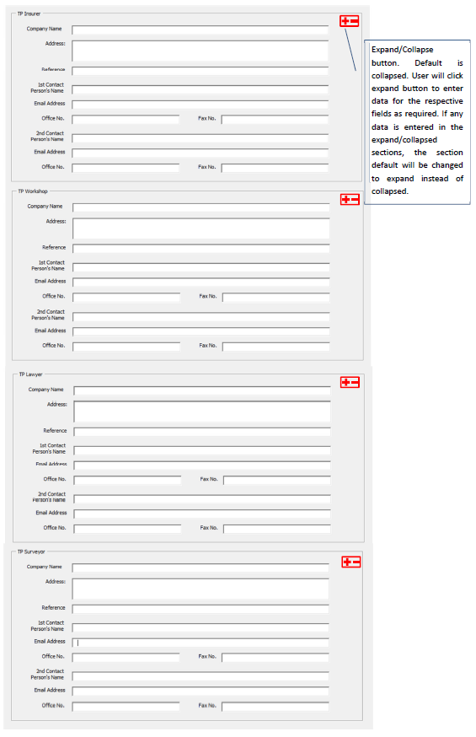

*Insert beside Company Name*

Active/Inactive (Default: Active)

Status: